**Experiment Number: 05**

**Problem Statement: Implement multithreading for matrix operation using Pthreads**

NAME: Manomay Jamble ROLLNO: 49

CLASS: TY (AI & DS) BATCH: 3

DATE OF PERFORMANCE: 06/10/2022

___________________________________________________________________________

**PROGARM:**

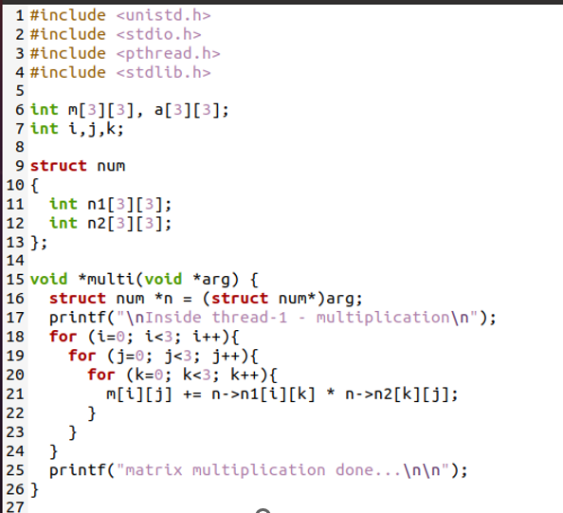

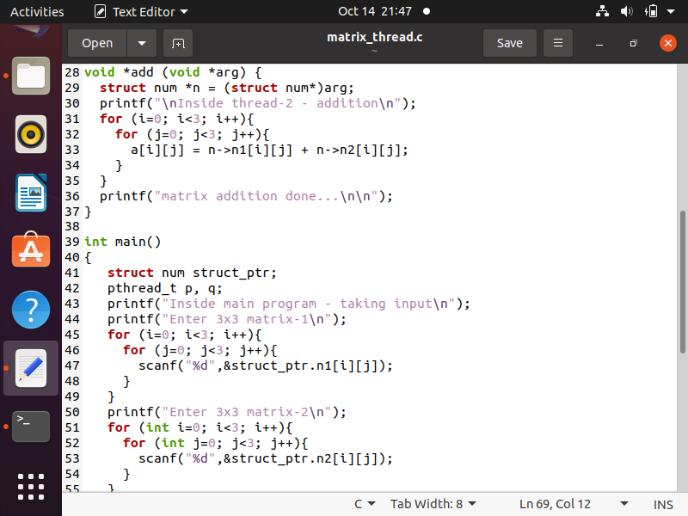

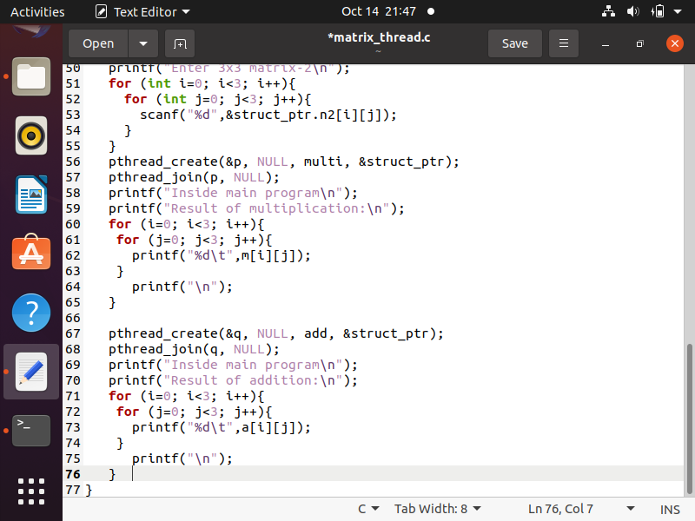

**OUTPUT:**



